LAB01

DC Circuits

Electronics - Hardware Tools for Embedded Software and IoT

Instructor: Jarno TUOMINEN

Author name: Uras Ayanoglu - 2203334

Author name: Sebastian Sopola – 1904705

Experiment contacted on: 07/09/2023

Report submitted on: 11/09/2023

Report edited on: 30.10.2023

Faculty of Engineering and Business

Information and Communication Technology

Turku University of Applied Sciences

Turku, Finland

**Table of Contents**

OBJECTIVES 1

BACKGROUND THEORY / INTRODUCTION 2

EQUIPMENT and COMPONENTS USED 3

PROCEDURE 3

Part 1: Measurement with Specified Resistors 4

Part 2: Replacement with E12 Series Resistors 4

Part 3: Replacement with a Potentiometer 5

DATA 5

Part 1: Measurement with Specified Resistors 5

Part 2: Replacement with E12 Series Resistors 5

Part 3: Replacement with a Potentiometer 6

FIGURES & GRAPHS 7

ANALYSIS 12

CONCLUSION 12

# OBJECTIVES

The primary objectives of this lab report are to explore and understand the principles of voltage dividers in direct current (DC) circuits and to analyze the effects of changing resistance values on current and voltage drops across resistors. The experiment involves setting up a DC circuit with a 10V DC source and four resistors (R1, R2, R3, and R4) to simulate and measure the current and voltage drops across each resistor. After the initial measurements, the resistors are changed, and the experiment is repeated to observe any variations in the results. In the final part of the experiment, the R2 and R3 resistors are replaced with a potentiometer, and the voltage drops across the resistors are measured again. This experiment aims to deepen the understanding of the relationship between resistance, voltage, and current in a DC circuits.

# BACKGROUND THEORY / INTRODUCTION

Voltage dividers are a fundamental concept in electrical engineering and electronics, playing a crucial role in various applications, from sensor interfacing to biasing transistors. A voltage divider is a simple circuit consisting of two or more resistors connected in series across a voltage source. The voltage across each resistor is proportional to its resistance and is a fraction of the input voltage. The principle governing the voltage divider is Ohm's Law, which states that the current passing through a conductor between two points is directly proportional to the voltage across the two points and inversely proportional to the resistance between them.

The theoretical foundation for voltage dividers is derived from Kirchhoff's voltage law, which states that the sum of the electromotive forces (emf) and the product of current and resistance in any closed loop of a circuit is zero. Based on this law, the voltage drop across a resistor in a series circuit can be calculated using the formula V=IR, where V is the voltage drop, I is the current, and R is the resistance. In a series circuit with multiple resistors, the total resistance (R_total) is the sum of the individual resistances, and the current (I) is the same through all resistors. Therefore, the voltage drop across each resistor can be determined by multiplying the current (I) by the resistance (R) of that resistor.

In this experiment, we will examine the voltage drops across individual resistors in a DC circuit with a 10V DC source and four resistors. By changing the values of the resistors and replacing two of them with a potentiometer, we aim to analyze the effects of varying resistance on the voltage drops across the resistors. This experiment will help to reinforce our understanding of the principles of voltage dividers and their practical applications in electronics.

# EQUIPMENT and COMPONENTS USED

For the first part of the experiment, no physical equipment or components were used as the entire experiment was conducted through simulation. The following software tools were used to simulate the experiment:

* LTSpice: It is a high-performance SPICE simulation software, schematic capture, and waveform viewer with enhancements and models for easing the simulation of analog circuits. In this experiment, LTSpice was used to simulate the DC circuit with a 10V DC source and four resistors, measure the current and voltage drops across each resistor, and observe the effects of changing resistance values and replacing resistors with a potentiometer.
* Multisim's Circuit Simulator Applet: This is an interactive online tool available at <https://www.multisim.com/create/> that allows users to build and simulate electronic circuits. This tool was used as an additional method to simulate the experiment and to visualize the current flow and voltage drops across the resistors in real-time.
* Biltema Art. 15-133 Multimeter, Fluke 112 True RMS Multimeter
* PicoScope 2005A Series Oscilloscope

Both of these simulation tools were essential in conducting the experiment as they allowed for the precise control and measurement of circuit parameters without the need for physical components or equipment. Additionally, the use of simulation tools eliminates the potential for measurement errors associated with physical experiments and allows for the easy modification and repetition of the experiment to observe different outcomes.

# PROCEDURE

The experiment was conducted in three parts, using the LTSpice simulation software and Falstad's Circuit Simulator Applet for the simulation and measurement of circuit parameters. Below are the detailed steps for each part of the experiment:

## Part 1: Measurement with Specified Resistors

1. Open the LTSpice software and create a new schematic.
2. Draw the circuit consisting of a 10V DC voltage source and four resistors (33k, 34k, 47k, and 5k) connected in series. Figure 1
3. Run the simulation and measure the current passing through the circuit and the voltage drops across each resistor. Record the measurements.
4. Calculate the total resistance of the circuit by adding the values of all four resistors. Use Ohm's law (V = IR) to calculate the current passing through the circuit and compare it with the simulated value.
5. Calculate the voltage drop across each resistor using the measured current and the resistance of each resistor. Compare the calculated values with the simulated measurements.

## Part 2: Replacement with E12 Series Resistors

1. Replace the resistors in the circuit with the closest values available in the E12 series in the LTSpice library which are R1 33.2k , R2 34k, R3 47.5k, and R4 4.99k. Figure 2
2. Run the simulation again and measure the current passing through the circuit and the voltage drops across each resistor. Record the measurements.
3. Repeat the calculations for the total resistance, current, and voltage drops as in Part 1 and compare the results with the simulated measurements.

## Part 3: Replacement with a Potentiometer

1. Replace the R2 and R3 resistors (34k and 47.5k) with a potentiometer with a value of 100k. Figure 3
2. Run the simulation and adjust the potentiometer to observe the range of voltage adjustment across the remaining resistors. Record the measurements at different potentiometer settings.
3. Analyze the measurements to determine the effect of the potentiometer on the voltage drops across the other resistors in the circuit.

Note: It is essential to verify the simulation results with theoretical calculations to ensure the accuracy of the experiment.

# DATA

## Part 1: Measurement with Specified Resistors

*Table 1: Point voltage values relative to the ground*

|  |  |  |  |  |  |
| --- | --- | --- | --- | --- | --- |
| POINTS | A | B | C | D | E |
| VOLTAGE | 10 V | 7.227 V | 4.369 V | 0.420 V | 0 V |

*Table 2: Voltage drops across resistors*

|  |  |  |  |  |
| --- | --- | --- | --- | --- |
| RESISTORS | R1 = 33K Ω | R2 = 34K Ω | R3 = 47K Ω | R4 = 5K Ω |
| VOLTAGE DROP | 2.772 V | 2.856 V | 3.948 V | 0.420 V |

## Part 2: Replacement with E12 Series Resistors

*Table 3: Point voltage values relative to the ground*

|  |  |  |  |  |  |
| --- | --- | --- | --- | --- | --- |
| POINTS | A | B | C | D | E |
| VOLTAGE | 10 V | 7.226 V | 4.385 V | 0.417 V | 0 V |

*Table 4: Voltage drops across resistors*

|  |  |  |  |  |
| --- | --- | --- | --- | --- |
| RESISTORS | R1 = 33.2K Ω | R2 = 34K Ω | R3 = 47.5K Ω | R4 = 4.99K Ω |
| VOLTAGE DROP | 2.774 V | 2.841 V | 3.969 V | 0.417 V |

*Table 3.1: Point voltage values relative to the ground from the physical design*

|  |  |  |  |  |  |
| --- | --- | --- | --- | --- | --- |
| POINTS | A | B | C | D | E |
| VOLTAGE | 10.01 V | 7.20 V | 4.4 V | 0.402 V | 0.002 V |

*Table 4.1: Voltage drops across resistors from the physical design*

|  |  |  |  |  |
| --- | --- | --- | --- | --- |
| RESISTORS | R1 = 32.85K Ω | R2 = 32.82K Ω | R3 = 47.12K Ω | R4 = 4.693K Ω |
| VOLTAGE DROP | 2.788 V | 2.785 V | 3.998 V | 0.400 V |

## Part 3: Replacement with a Potentiometer

*Table 5: Point voltage values relative to the ground – When R2 is 10 %, 25 %, 50 % and 100 % respectively*

|  |  |  |  |  |
| --- | --- | --- | --- | --- |
| POINTS | A | B | C | E |
| VOLTAGE | 10 V | 3.094 V | 1.038 V | 0 V |

|  |  |  |  |  |
| --- | --- | --- | --- | --- |
| POINTS | A | B | C | E |
| VOLTAGE | 10 V | 4.754 V | 0.804 | 0 V |

|  |  |  |  |  |
| --- | --- | --- | --- | --- |
| POINTS | A | B | C | E |
| VOLTAGE | 10 V | 6.248 V | 0.598 V | 0 V |

|  |  |  |  |  |
| --- | --- | --- | --- | --- |
| POINTS | A | B | C | E |
| VOLTAGE | 10 V | 7.610 V | 0.410 V | 0 V |

*Table 6: Voltage drops across resistors -- When R2 is 10 %, 25 %, 50 % and 100 % respectively*

|  |  |  |  |
| --- | --- | --- | --- |
| RESISTORS | R1 = 33.2K Ω | R2 = 10K Ω | R4 = 4.99K Ω |
| VOLTAGE DROP | 6.906 V | 2.080 V | 1.038 V |

|  |  |  |  |
| --- | --- | --- | --- |
| RESISTORS | R1 = 33.2K Ω | R2 = 25K Ω | R4 = 4.99K Ω |
| VOLTAGE DROP | 5.246 V | 3.950 V | 0.788 V |

|  |  |  |  |
| --- | --- | --- | --- |
| RESISTORS | R1 = 33.2K Ω | R2 = 50K Ω | R4 = 4.99K Ω |
| VOLTAGE DROP | 3.752 V | 5.650 V | 0.564 V |

|  |  |  |  |
| --- | --- | --- | --- |
| RESISTORS | R1 = 33.2K Ω | R2 = 100K Ω | R4 = 4.99K Ω |
| VOLTAGE DROP | 2.390 V | 7.200 V | 0.359 V |

*Table 6.1: Voltage drops across resistors -- When R2 is 10 %, 25 %, 50 % and 100 % respectively from the physical design*

|  |  |  |  |
| --- | --- | --- | --- |
| RESISTORS | R1 = 33.85K Ω | R2 = 10.02K Ω | R4 = 4.693K Ω |
| VOLTAGE DROP | 6.98 V | 2.11 V | 0.920 V |

|  |  |  |  |
| --- | --- | --- | --- |
| RESISTORS | R1 = 33.85K Ω | R2 = 25.08K Ω | R4 = 4.693K Ω |
| VOLTAGE DROP | 5.265 V | 4.059 V | 0.686 V |

|  |  |  |  |
| --- | --- | --- | --- |
| RESISTORS | R1 = 33.85K Ω | R2 = 49.96K Ω | R4 = 4.693K Ω |
| VOLTAGE DROP | 3.781 V | 5.759 V | 0.470 V |

|  |  |  |  |
| --- | --- | --- | --- |
| RESISTORS | R1 = 33.85K Ω | R2 = 93.9K Ω | R4 = 4.693K Ω |
| VOLTAGE DROP | 2.584 V | 7.424 V | 0.002 V |

*Table 7: Relationship between current and voltage drop values across the potentiometer*

|  |  |  |
| --- | --- | --- |
| Potentiometer Value | Current (mA) | Voltage (V) |
| 10 % | 0.194 | 2.080 |
| 25 % | 0.144 | 3.950 |
| 50 % | 0.099 | 5.650 |
| 100 % | 0.04 | 7.200 |

# FIGURES & GRAPHS

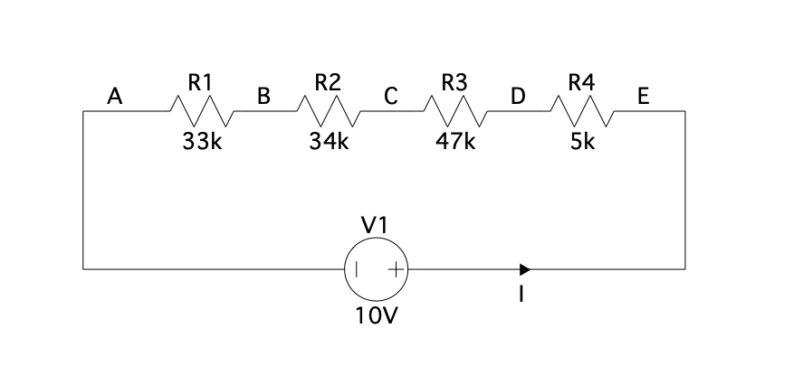

*Figure 1: Schematic of the experimental setup for part 1 in LTSpice.*

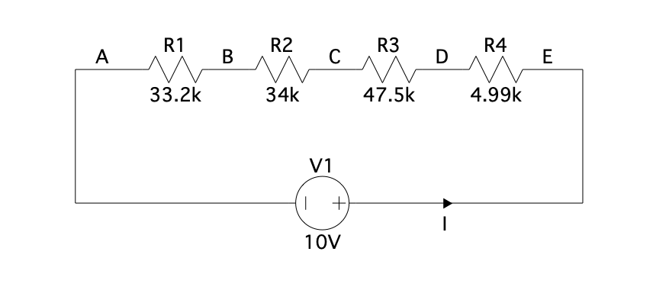

*Figure 2: Schematic of the experimental setup for part 2 in LTSpice.*

*Figure 3: Schematic of the experimental setup for part 3 in LTSpice.*

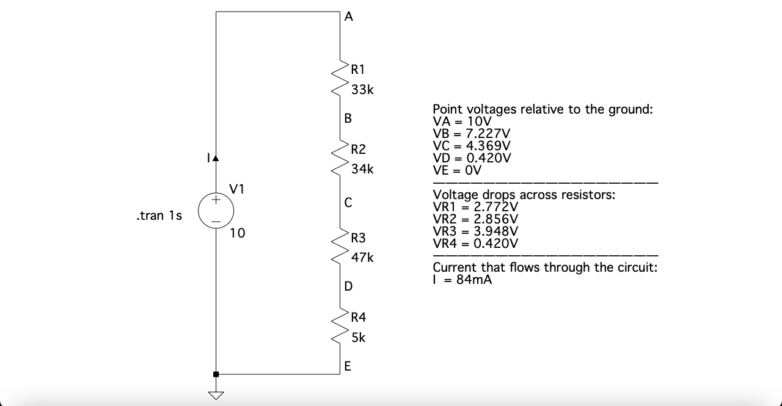

*Figure 4: Voltage drops and current measurements of the circuit design in Part 1 .*

*Figure 5: Voltage drops and current measurements of the circuit design in Part 2*

*Figure 6: Point voltages relative to ground graph for Part 1 and Part 2*

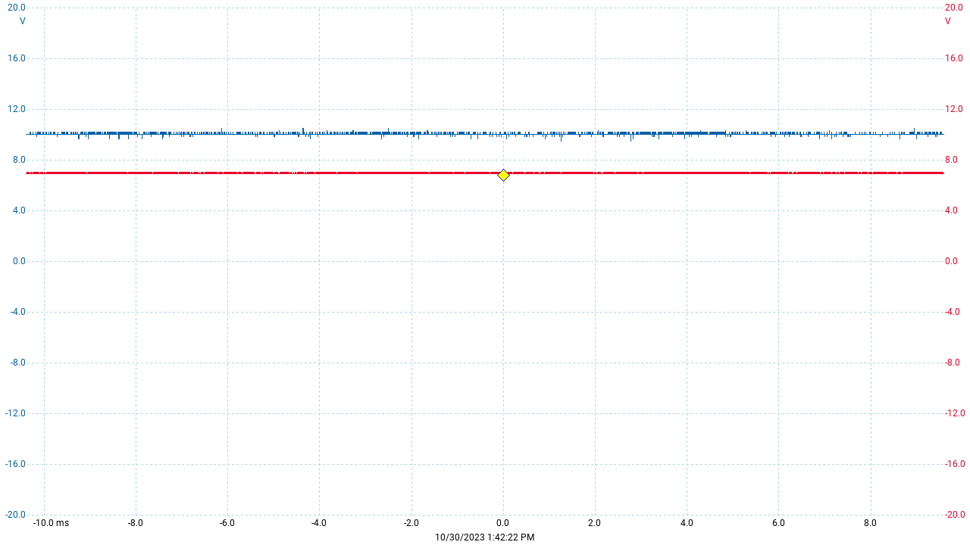*Figure 7: Voltage drops across points A and B*

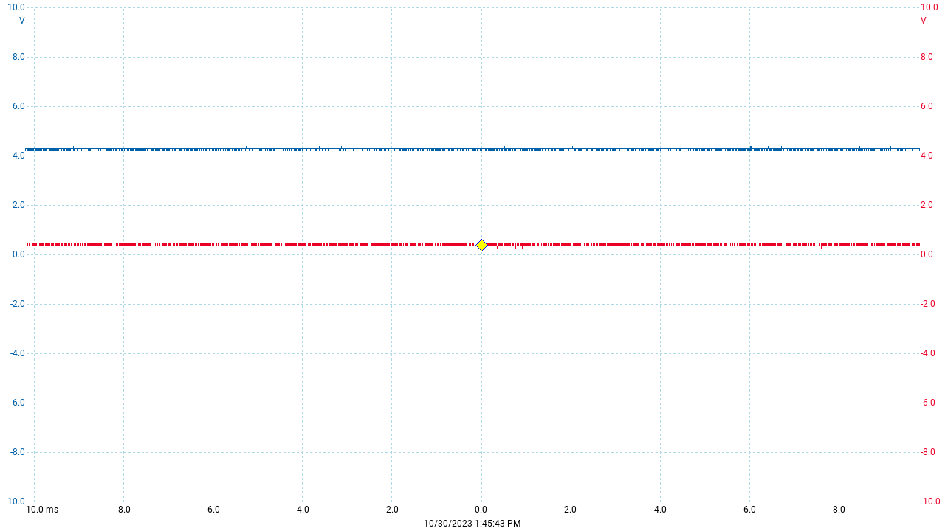*Figure 8: Voltage drops across points C and D*

# ANALYSIS

The experiment was conducted in three parts to understand the principles of voltage dividers in DC circuits, and to analyze the effects of changing resistance values on current and voltage drops across resistors.

In Part 1, a circuit with specified resistors was simulated. The theoretical total resistance of the circuit was calculated by summing up the resistance values of all four resistors (33kΩ + 34kΩ + 47kΩ + 5kΩ = 119kΩ). Using Ohm's law (V = IR), the theoretical current passing through the circuit was calculated as 10V / 119kΩ = 84.03 µA. The simulated results showed a current passing through the circuit of approximately 84.03 µA, which matches with the theoretical value. The voltage drops across each resistor were also measured and compared with the calculated values. The simulated voltage drops across the resistors R1, R2, R3, and R4 were 2.772V, 2.856V, 3.948V, and 0.420V respectively, which closely match the calculated values.

In Part 2, the resistors were replaced with the closest values available in the E12 series, and the simulation was run again. The theoretical total resistance of the circuit with the E12 series resistors was calculated as 33.2kΩ + 34kΩ + 47.5kΩ + 4.99kΩ = 119.69kΩ, and the theoretical current was 10V / 119.69kΩ = 83.60 µA. The simulated current was approximately 83.60 µA, and the simulated voltage drops across the resistors were 2.774V, 2.841V, 3.969V, and 0.417V, which closely match the calculated values.

In Part 3, resistors R2 and R3 were replaced with a potentiometer, and the simulation was run again at different potentiometer settings. As the resistance of the potentiometer increased, the current through the circuit decreased, and the voltage drop across the potentiometer increased. For example, when the potentiometer was set to 10% (10kΩ), the current was 0.208 mA, and the voltage drop across the potentiometer was 2.080V. When the potentiometer was set to 100% (100kΩ), the current decreased to 0.072 mA, and the voltage drop across the potentiometer increased to 7.200V.

# CONCLUSION

The experiment successfully demonstrated the principles of voltage dividers in DC circuits and the effects of changing resistance values on current and voltage drops across resistors. The simulated results closely matched the theoretical calculations, validating the accuracy of the simulation tools used. The experiment showed that the total resistance of a series circuit is the sum of the individual resistances, and the current passing through the circuit is inversely proportional to the total resistance. It was also observed that the voltage drop across a resistor in a series circuit is directly proportional to its resistance. Additionally, the experiment demonstrated that a potentiometer can be used to adjust the voltage drops across the resistors in a circuit by varying its resistance. This experiment deepened the understanding of the relationship between resistance, voltage, and current in DC circuits and reinforced the principles of voltage dividers and their practical applications in electronics.